**Wheels of Danger**

***A Data-Driven Dive into Kenya’s Road Traffic Crisis***

Uncover the when, where, and why of Nairobi’s and Kenya’s deadliest crashes. From fatal hotspots to emergency response delays, this report turns raw traffic data into actionable insight—and a wake-up call for urgent reform.

**The Road to This Moment**

Every day, across Kenya’s roads, lives are cut short.  
**Road traffic crashes are now one of the leading causes of death globally**, especially among young adults—and in Kenya, they claim the lives of thousands each year, disproportionately striking people aged **15 to 64**, the nation’s most productive population.

Though Kenya owns only a **fraction of the world’s vehicles**, it bears a **disproportionate burden of global traffic deaths**. In Nairobi, the situation is dire: trauma response is overstretched, dangerous roads remain unmodified, and **emergency response times average 162 minutes**, far beyond the **8-minute WHO benchmark**.

The toll is more than human. Road crashes drain **3–5% of Kenya’s GDP**, stretch hospital systems thin, and erode family incomes. Still, the crisis worsens—unfolding daily on city highways, rural junctions, and in the silence after every siren.

This report follows the data. And the data doesn’t lie.

**Research Questions**

1. How do road traffic death rates vary across continents and African countries, and where does Kenya rank globally and regionally over recent years?

2. How has the frequency and severity of road crashes evolved over time across Kenyan counties, and are specific regions becoming increasingly dangerous?

3. What are the spatiotemporal patterns of road crashes within Nairobi and its environs?

4. How has the distribution of road crashes in Nairobi changed across years, and are there identifiable demographic patterns (e.g., age, gender, victim type)?

5. How do road crashes in Nairobi vary by month and quarter, and what seasonal trends can be observed?

6. How do crash characteristics differ by day of the week, and what are the weekday vs weekend variations in fatality and pedestrian involvement?

7. How does crash frequency and severity vary by time of day, and are specific hours (e.g., peak commuting times) associated with higher crash risk?

8. To what extent do matatus and motorcycles feature in road crash reports, and how does their presence relate to severity across time (hour, day, month)?

9. What are the primary causes of road traffic accidents globally, in Kenya, and specifically in Nairobi over time?

10. How do emergency response time and proximity to healthcare facilities influence fatality outcomes in Nairobi crashes?

**Where the Data Leads**

**1. How do road traffic death rates vary across continents and African countries, and where does Kenya rank globally and regionally over recent years?**

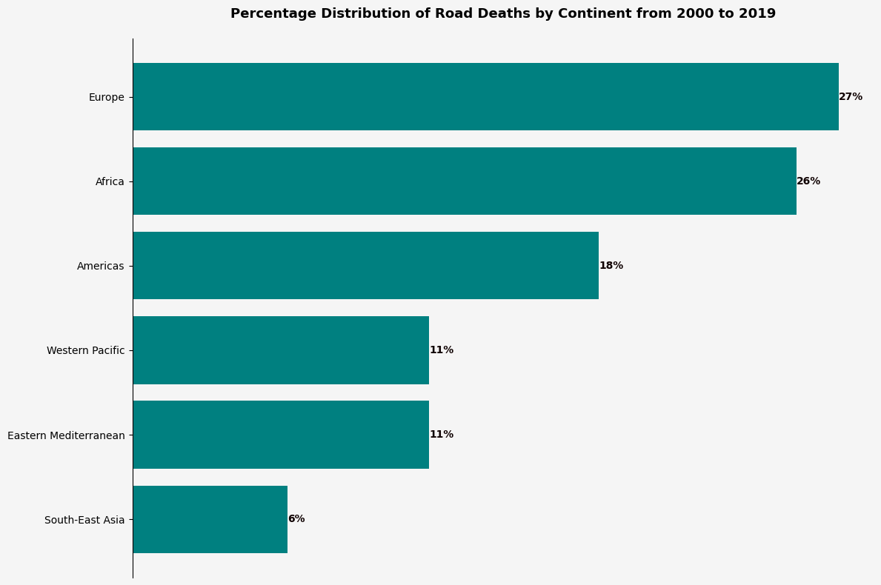

As of 2019, Europe recorded the highest percentage of global road traffic deaths at approximately **27%**, followed closely by Africa at **26%**, as shown in the bar graph.

However, the **Africa Status Report on Road Safety (2025)** confirms that Africa has now overtaken Europe in fatality share, despite owning less than **4%** of the world’s vehicles.

This rise reflects major deficits in enforcement, road infrastructure, and trauma care systems across the continent.

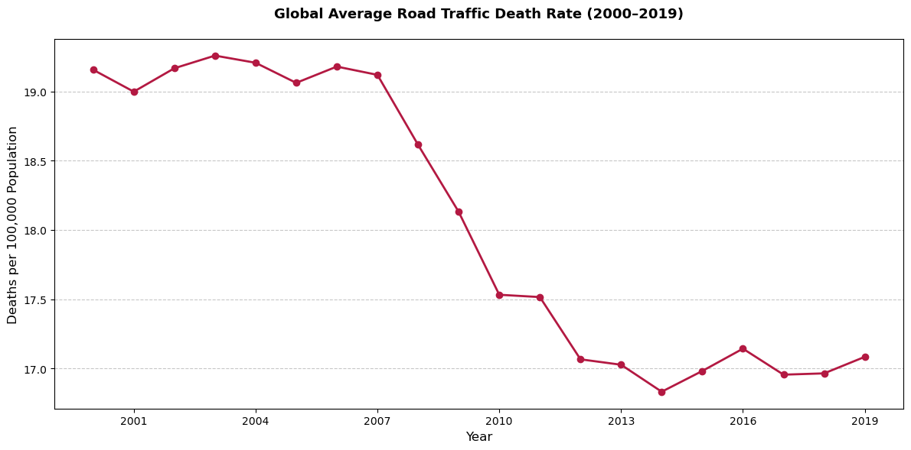

The line graph illustrates stagnation in global fatality rates, holding steady at 17–18 deaths per 100,000 population from 2000 to 2019. High-income regions—such as Western Europe, North America, and Australia—have reduced their average rates to under 10 per 100,000, thanks to safer vehicles, strict enforcement, and accessible emergency services.

In contrast, Africa now exceeds 26.6 per 100,000. Kenya, with **28.2 deaths per 100,000**, ranks **6th in Africa** behind Libya, Guinea-Bissau, Liberia, Chad, and Guinea, and is among the top 10 globally. Fatalities in Kenya rose to **3,581–4,748** in 2024.

To reverse this trend, we as Kenyans must adopt proven interventions. These include automated enforcement (speed, seatbelts, alcohol), mandatory protective gear for riders, and PSV regulation. Pedestrian infrastructure—such as footbridges, crossings, and reflective signage—should be prioritized. Europe’s implementation of pedestrian zones and enforced crossings has cut pedestrian deaths by **over 36% in the past decade** (European Transport Safety Council, 2023).

**2. How has the frequency and severity of road crashes evolved over time across Kenyan counties, and are specific regions becoming increasingly dangerous?**

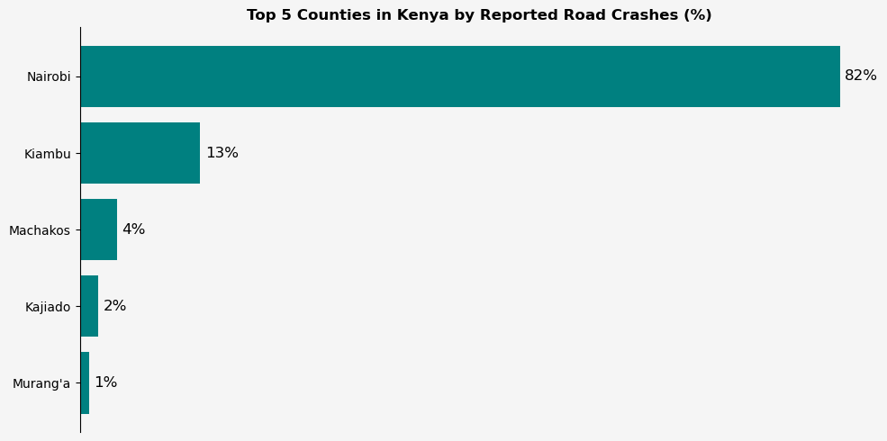

Based on the World Bank crash analysis, **Nairobi, Kiambu, Machakos, Kajiado, and Murang’a** recorded the highest percentage of reported crashes, with **Nairobi alone accounting for 82%**. Nairobi’s dominance is attributed to high traffic density, complex urban networks, and a large pedestrian base. **Kiambu**, closely linked to Nairobi via key roads such as **Thika Road**, **Limuru Road**, and **Waiyaki Way**, ranks second. Additionally, the **NTSA 2025 report** highlights **Nakuru** as a critical hotspot due to its location along the **Northern Corridor**, particularly the **A104 highway**, where **55% of Nakuru’s fatalities** occur.

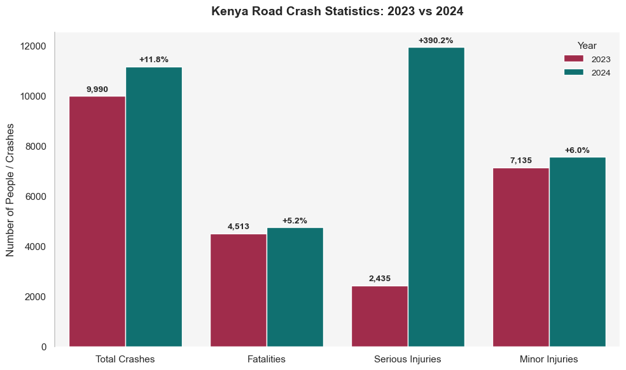

The bar plot of **2023 vs 2024 crash statistics** reveals an alarming increase: **total crashes rose from 9,990 to 11,173**, and **fatalities climbed from 4,513 to 4,748**—a **9.8% rise**, according to **NTSA (2025)**.

**Serious injuries more than quadrupled**, from **2,435 to 11,937**, showing a sharp rise in crash severity. Although **Q1 2025** recorded **1,139 fatalities**, slightly down from the previous quarter (**NTSA, 2025**), the overall trend remains upward.

Historical data supports this trajectory: from **427 crashes (49 deaths)** in 2002 to **1,755 crashes (260 deaths)** in 2010, and a **26% rise in fatalities and 46% rise in injuries** between 2015 and 2020.

**Spatial and Causal Risk Patterns**

The **A104 corridor** remains the deadliest route, especially sections like **Kinungi–Gilgil**, **Sobea–Salgaa–Mau Summit**, and **Timboroa–Burnt Forest**, which suffer from fog, poor signage, and steep gradients. Segments like **Chepsir–Kipkelion** and **Molo GSU–Salgaa** pose constant threats due to sharp curves, inadequate markings, and heavy truck traffic. These areas consistently report high crash rates, particularly involving long-distance trucks and pedestrians. Immediate interventions must focus on **road geometry improvements, signage, freight-passenger separation, and hotspot-specific enforcement**.

**3. What are the spatiotemporal patterns of road crashes within Nairobi and its environs?**

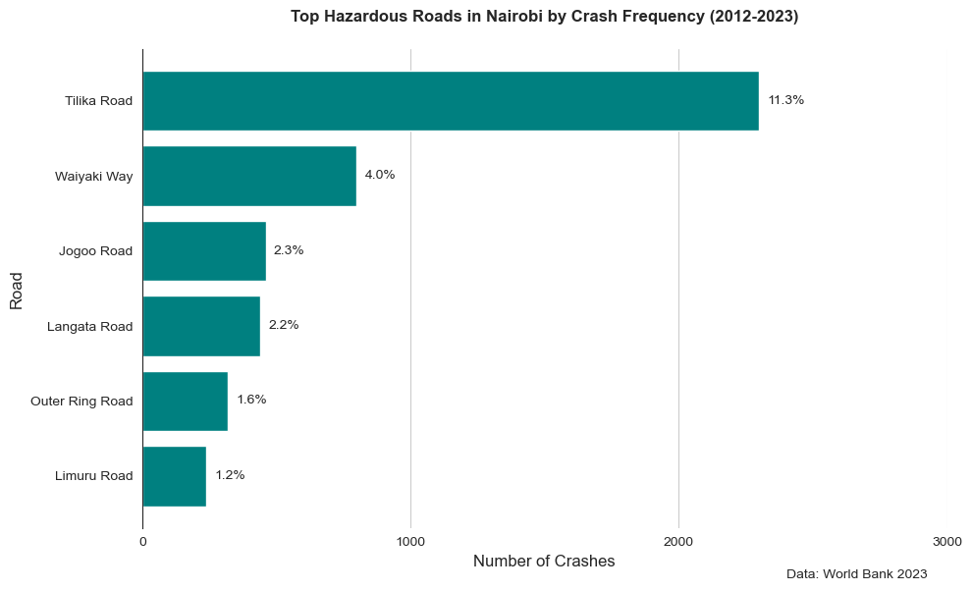

According to World Bank analysis (2012–2023), Thika Superhighway remains Nairobi’s most hazardous corridor, accounting for 11% of all reported crashes. This is largely due to its high traffic volume—averaging 150,000 vehicles daily—combined with insufficient pedestrian crossings and frequent informal road usage at junctions. Waiyaki Way, contributing 4%, follows closely, primarily because of narrow footpaths, poor lighting, and high-speed driving through densely populated areas. Jogoo Road accounts for 2.3%, driven by the mix of intense matatu operations, heavy pedestrian flow, and market-related congestion. Similarly, Mombasa Road is a critical blackspot, worsened by industrial traffic, frequent U-turns, and limited pedestrian infrastructure, making it a high-risk zone for vulnerable road users.

**Spatial Concentration of Crashes**

Crashes in Nairobi are **geographically clustered**. A World Bank spatial analysis found that **10 specific hotspots accounted for 10% of all crashes**, while **100 micro-clusters accounted for 50%**, confirming that a few critical points bear a disproportionate share of road trauma. These clusters align with **transport interchanges, highway exits, matatu stages, and unregulated markets**, where pedestrian activity intersects with high-speed vehicular flow.

**Temporal Patterns and Peak Risk Windows**

Crash risk intensifies during **evenings (especially 7–8 pm)** and **weekends**, with **Saturdays alone accounting for 855 deaths in 2024 (NTSA, 2025)**. Hospital data from 2011 showed **42% of pedestrian crashes occurred on weekends**, a pattern confirmed by NTSA’s national reporting. **December** consistently records the highest fatalities (466 in 2024), tied to increased travel, festivities, and relaxed enforcement. Most victims are **pedestrians**, comprising **65–74% of all fatalities**, often struck while crossing roads, typically at non-designated points.

**4. How has the distribution of road crashes in Nairobi changed across years, and are there identifiable demographic patterns (e.g., age, gender, victim type)?**

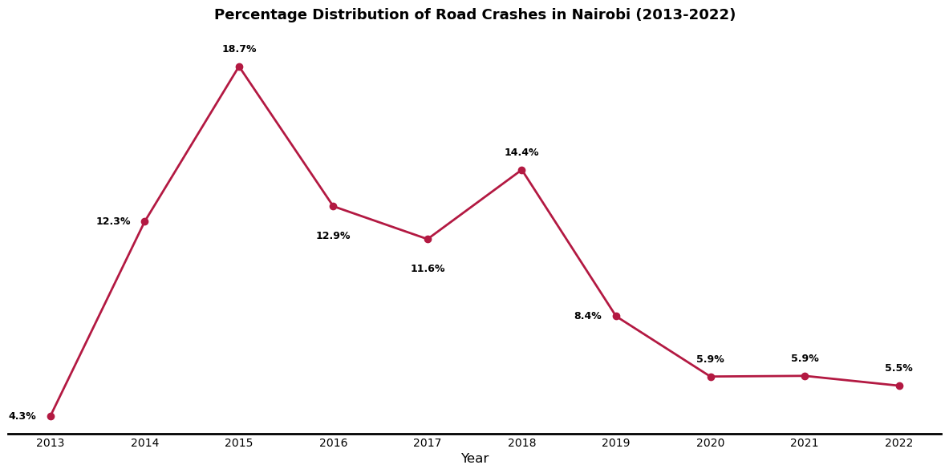

**Percentage Distribution of Road Crashes in Nairobi (2013–2022)**  
The line graph indicates a sharp increase in crash fatalities in Nairobi between 2013 and 2015, peaking in 2015. This spike is attributed to rapid urban expansion, increased vehicle ownership, and a surge in motorcycle use, particularly by untrained young riders entering the informal transport sector. During this period, enforcement was weak, and infrastructure failed to adapt to Nairobi’s growing traffic complexity.

From 2016 to 2019, the trend stabilized but remained elevated, reflecting sustained risk in high-crash corridors like Thika Road and Mombasa Road. In 2020, crash reports dropped significantly, largely due to COVID-19 restrictions such as curfews, reduced travel, and enforcement of social distancing. However, by 2021–2022, crash numbers began to rise again as normal activity resumed, yet without substantial improvements in infrastructure or enforcement.

**Temporal and Road-Specific Trends**  
Between **2015 and 2020**, fatalities rose by **26%**, and injuries by **46.5%**, underscoring a trend toward **greater crash severity** rather than just increased frequency. Major arterial roads continue to pose heightened risk, particularly where **informal crossings**, **speeding**, and **matatu stopovers** dominate. These persistent patterns highlight the **failure of passive interventions** and the need for targeted structural and behavioural reforms.

**Demographic Risk Profiles**  
Men remain the most affected, comprising **over 70% of crash fatalities**, with the majority aged **15–64 years**—the economically active population. This pattern correlates with the rise of **motorcycles as a dominant mode of transport**, especially among **youths seeking quick income**.

As of **2024**, Kenya had **over 2.5 million registered motorcycles**, a sharp rise from **less than 700,000 in 2015** (NTSA, 2024). The growth has been fueled by **mobile loan schemes** that make it easy to acquire motorcycles, often without mandatory **rider training or licensing**. Many of these riders are **recent school leavers**, lacking road safety awareness, and are involved in a disproportionate share of Nairobi’s crashes.

Motorcyclists and pillion passengers now account for a large portion of severe injuries and deaths. The absence of protective gear, overloading, and speeding further compounds their vulnerability. Pedestrians also remain high-risk victims, particularly near **markets, residential estates, and highway crossings** lacking formal footbridges or signage.

**5. How do road crashes in Nairobi vary by month and quarter, and what seasonal trends can be observed?**

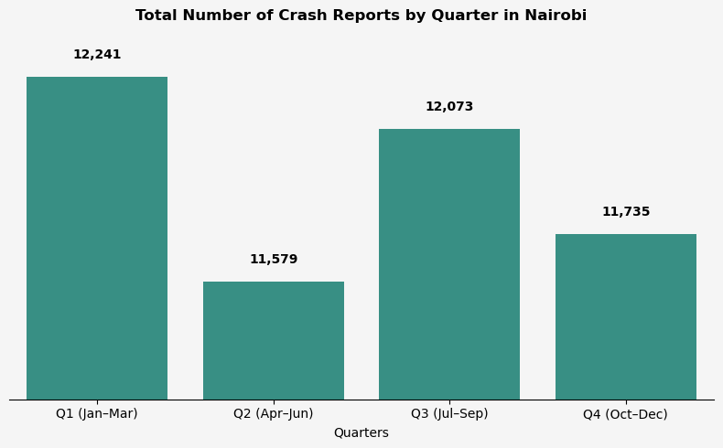

The bar graph indicates that Q1 (Jan–Mar) recorded the highest number of crash reports, likely due to increased travel during the festive season spillover and school reopenings in January, leading to higher traffic volumes. It was followed by Q3 (Jul–Sep), possibly linked to mid-year economic activities and travel. Q4 (Oct–Dec) came next, encompassing the December festive period, though its slightly lower figures might be due to underreporting or effective pre-holiday safety campaigns. Lastly, Q2 (Apr–Jun) had the lowest, potentially due to fewer travel activities during this period.

However, NTSA's 2025 report highlights that December 2024 alone recorded 466 fatalities—the highest in a single month—underscoring Q4's elevated risk. The first quarter of 2025 experienced 1,139 fatalities, indicating a persistent upward trend.

Factors such as alcohol-related incidents, driver fatigue from long-distance travel, and risky overtaking on major corridors like Thika Road, Mombasa Road, and Waiyaki Way contribute to this surge.

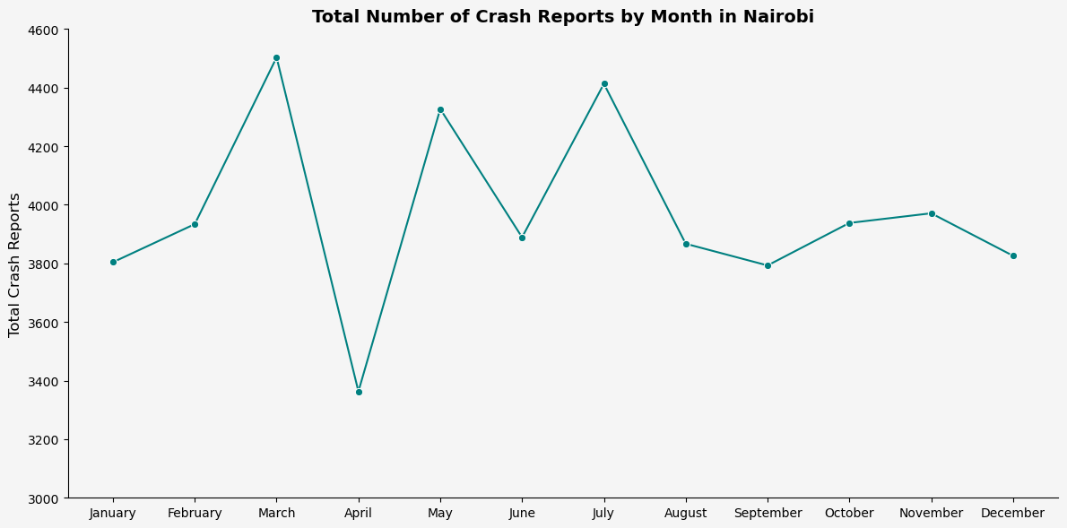

The line graph reveals that March, July, and May had the highest number of crash reports, while April recorded the lowest. The sharp decline in April aligns with the rainy season, where flooded roads, potholes, and stalled vehicles contribute to reduced mobility and fewer reported crashes. This trend is supported by findings from Science Africa (2024), which cite these factors as key contributors to road chaos during the rainy months. Conversely, the higher numbers in March, July, and May may be attributed to increased travel and economic activities during these periods.

**6. How do crash characteristics differ by day of the week, and what are the weekday vs weekend variations in fatality and pedestrian involvement?**

The line graph shows that **crash reports peak on Fridays**, followed by **Tuesdays and Wednesdays**. These are active workdays with **high vehicular and pedestrian traffic**, especially during morning and evening rush hours. Congestion, impatience, and route overlaps increase crash likelihood on these days.

Conversely, **weekends record fewer total crashes**, with **Sundays reporting the lowest**. This is due to reduced work commutes and lower vehicle density. However, **weekend crashes—especially on Saturdays—are more fatal**, often involving **speeding, alcohol influence**, and **free-flowing highway travel**.

NTSA’s 2024 data confirms that **Saturdays recorded 855 fatalities**, the highest of any day. High-speed roads like **Thika Road and Waiyaki Way** are frequent crash sites, especially for **pedestrians crossing informally**.

Pedestrians are consistently the most affected group, especially during weekends. Crash trauma data shows **limb injuries are most common**, with **pillion passengers and unhelmeted riders** also dominating weekend hospital admissions.

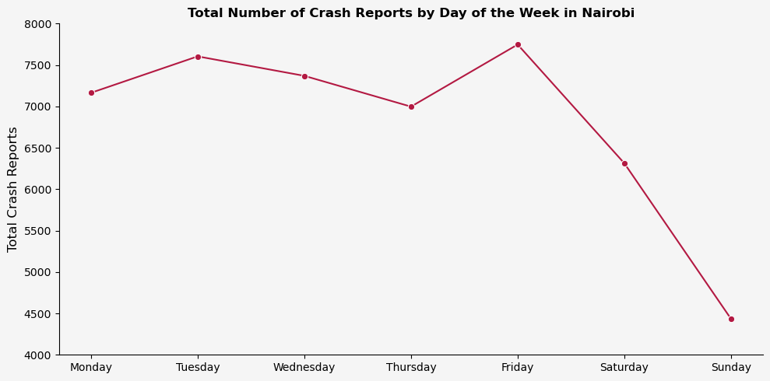

**7. How does crash frequency and severity vary by time of day, and are specific hours (e.g., peak commuting times) associated with higher crash risk?**

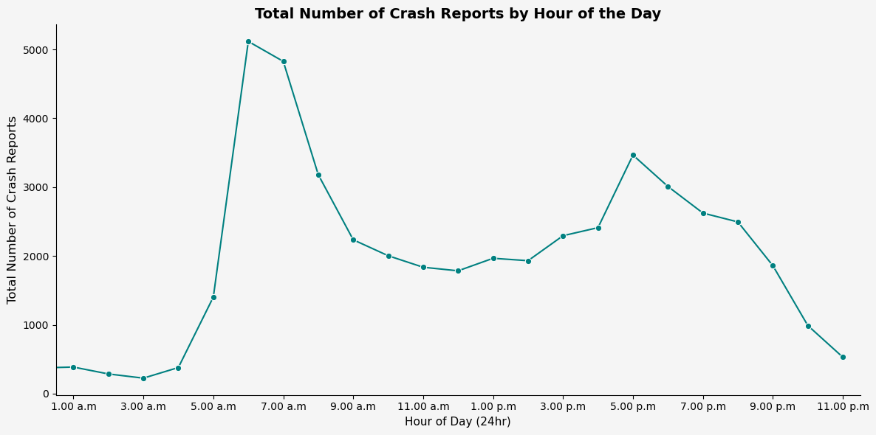

The line graph shows two critical spikes: one between 7:00–9:00 AM and another between 4:00–8:00 PM. These correspond to Nairobi’s peak commuting windows, confirming that morning and evening rush hours are high-risk periods due to traffic congestion, fatigue, and time pressure among motorists.

The steep rise in crash frequency during the 7–9 AM bracket is also supported by NTSA's 2025 observation of increased crashes during early hours on Mondays—often linked to rushed commuting and poor alertness following weekend rest.

From 8:00 PM onwards, there's a gradual tapering off; however, nighttime driving carries disproportionate fatality risk. Reduced visibility, impaired drivers, and speeding during low-traffic conditions elevate crash severity after dark.

Dawn (5:00–6:00 AM) and dusk (6:00–7:00 PM) hours exhibit moderate crash frequencies. This may be attributed to rapidly changing lighting conditions which affect depth perception and pedestrian visibility, especially on poorly lit roads.

**8. To what extent do matatus and motorcycles feature in road crash reports, and how does their presence relate to severity across time (hour, day, month)?**

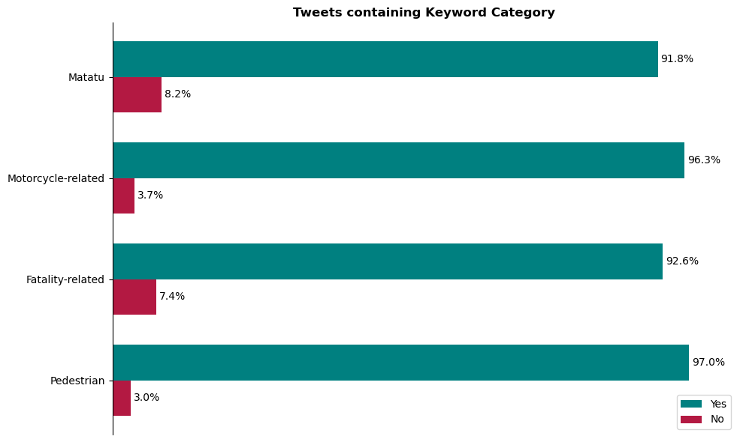

The graph shows that **matatu-related crash mentions account for 8.2%** of all tweets, while **motorcycle-related mentions are just 3.7%**. This confirms that **matatus feature more prominently** in public crash reporting, suggesting either higher involvement or greater public visibility of these incidents.

Despite motorcycles having lower representation in the data, their crash outcomes tend to be more severe. Riders and pillion passengers often lack protective gear, making even minor collisions fatal. This aligns with **NTSA’s observations** that motorcycles disproportionately contribute to trauma unit admissions, especially during weekends and nighttime hours.

Matatus dominate urban crash involvement due to their **reckless driving, frequent lane changes**, and pressure to meet trip quotas. Their involvement increases during **peak hours**, where congested traffic magnifies the impact of poor driving behaviour.

Motorcycle crashes spike in **wet months** (April, October), where visibility is reduced and braking is unstable. Many riders are **untrained youth** who acquired bikes through mobile credit loans without formal licensing—a trend flagged in **NTSA’s 2024/25 reports**.

**9. What are the primary causes of road traffic accidents globally, in Kenya, and specifically in Nairobi over time?**

On **February 24, 2023**, during a road safety training for boda boda riders in Meru, **County Commissioner Fredrick Ndunga** emphasized that road accidents are now among the **leading causes of death in Kenya**, rivaling diseases like cancer. **Engineer Tom Omae** of the **Kenya Roads Board** supported this by citing NTSA data: **4,690 fatalities in 2022**, with **442 deaths from boda boda passenger incidents**. He stated that **over 80% of crashes were caused by human behavior**—speeding, alcohol use, reckless overtaking, and phone-related distractions. In response, 15 counties have received safety training, with over 5,000 riders trained and thousands of safety kits distributed.



On **March 21, 2024**, then **Interior CS Kithure Kindiki** described road crashes as a **“national catastrophe”** on his verified X account. He announced strict measures aligned with Section 69 of the Traffic Act, including **the arrest of 22,958 drivers**, seizure of **6,692 motorcycles**, and **collection of Ksh.300 million in fines** from January–February 2024 alone. He confirmed that **drunk driving led to 1,086 arrests** and **motorcycle crashes caused 255 deaths** in the same period. His directive included **retrofitting roads**, **introducing speed cameras**, and **retesting drivers** to address escalating fatalities. He labeled **corruption on Kenyan roads a national security threat**, highlighting the systemic failure in enforcing traffic discipline.

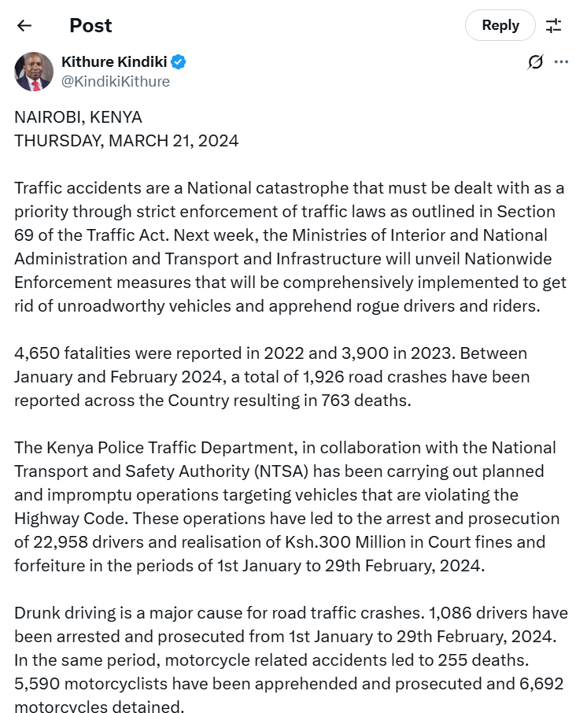



The **horizontal bar graph** shows that the top cause of road fatalities in Q4 2024 was **“Losing control” (243 deaths)**. Other leading causes include **untraced causes (170 deaths)**, **failing to keep proper lanes (154)**, and **dangerous overtaking (105)**. Notably, behavioural errors like **“proceeding at excessive speed” (53 deaths)** and **“error of judgment or negligence” (62 deaths)** dominate the list. The data affirms NTSA’s assertion that over **85% of crashes are driven by preventable human error**, particularly speeding and reckless manoeuvres.

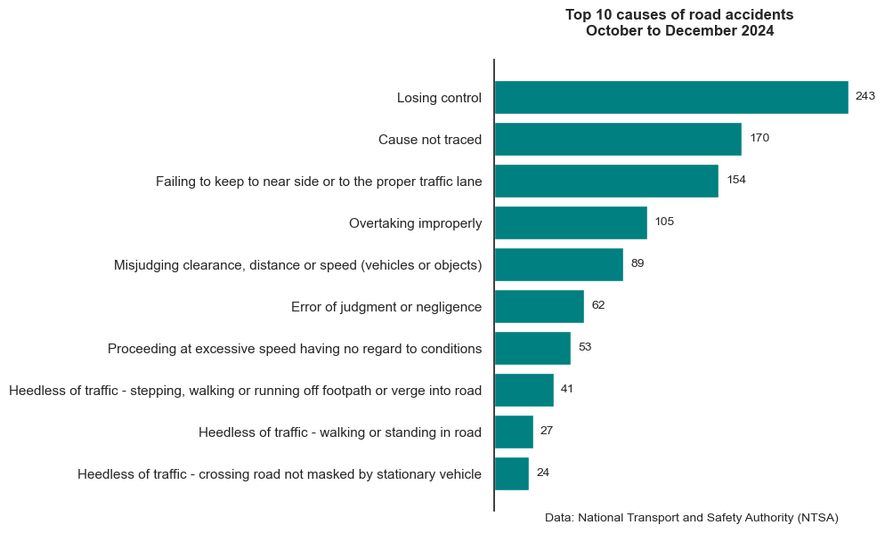

From the broader perspective, global crash causes mirror Kenya’s: **speeding, drunk driving, distraction, and reckless behavior** remain dominant. In Nairobi, the challenge is compounded by **urban congestion, poor road design, and uncontrolled motorcycle proliferation**. Increased motorization and informal transport systems have outpaced infrastructure upgrades, resulting in **systemic exposure to high-risk interactions between pedestrians, boda bodas, and matatus**.

Recent NTSA data indicate **3,900 road fatalities in 2023**, and by **February 2024**, **1,926 crashes and 763 deaths** had already been recorded. This reflects an **accelerating crisis**, especially with motorcycles and informal PSVs contributing to disproportionate casualties. High-speed corridors like **Thika Road**, and chaotic informal stops in Nairobi’s CBD, amplify the risk. Enforcement has been reactive rather than preventive, often undermined by bribery and inconsistent patrols.

**10. How do emergency response time and proximity to healthcare facilities influence fatality outcomes in Nairobi crashes?**



Emergency response time is a critical determinant of survival in trauma cases. According to **WHO**, pre-hospital response should occur within **eight minutes**, but in **Nairobi**, average response time is **162 minutes**—a 20x deviation from global standards. This delay severely compromises patient outcomes, especially within the **golden hour** of care.

A study by **Shaw et al. (2017)** found significant **gaps in the spatial distribution of trauma-capable facilities** in Nairobi. Many high-crash zones—particularly in Eastlands, Kangemi, and Pipeline—lie far from hospitals with **trauma surgery capacity**, increasing pre-hospital time and associated fatality risk.

Due to limited ambulance availability, victims are often transported by **private cars, police vehicles, or boda bodas**. This informal emergency chain introduces delays, improper handling, and poor triage—all of which increase the likelihood of death or long-term disability.

High dependency on **Kenyatta National Hospital** overstretches resources, resulting in congestion, long wait times, and strained trauma care. Peripheral hospitals often lack surgical capacity, further delaying life-saving interventions.

Traffic congestion further amplifies delays. Even small hold-ups during **peak hours** or on poorly connected roads can mean the difference between survival and fatality, particularly for patients with **hemorrhage or head trauma**.

Socioeconomic disparities worsen access. Patients from **low-income informal settlements** often lack insurance and face barriers to admission or referral, prolonging the time before definitive care is initiated.

**What Citizens Can Do: Steering Ourselves to Safety**

**1. 🧠 Think Before You Cross**

Most pedestrian deaths in Nairobi happen while crossing roads—often at undesignated points. Use footbridges, zebra crossings, and avoid darting between vehicles. At night, wear bright or reflective clothing to increase visibility, especially in areas like Jogoo Road or Waiyaki Way where drivers often don’t expect pedestrians.

**2. 🛵 Ride Smart, Ride Right**

Motorcycles (boda bodas) are involved in thousands of injuries and deaths annually. If you're a rider, always wear a certified helmet and reflective vest. If you're a passenger, never accept a ride from someone without protective gear. Get proper training before riding—most fatalities involve untrained or underage riders.

**3. 🍺 Reject Drunk Driving—Even from Friends**

Over 1,000 drunk drivers were arrested in just two months in early 2024. Don’t risk your life or others’. Never drive under the influence, and never board a vehicle with a driver who appears intoxicated—whether it's a friend, boda boda, or matatu operator. Speak up or call for help.

**4. 📵 Stay Off Your Phone on the Road**

Distracted driving or walking—especially while texting or using social media—is a growing crash cause. If you’re a pedestrian, stay alert when crossing. If you're driving, one second of screen time can cause a lifetime of regret. Nairobi’s peak crash hours demand your full attention.

**5. 🕒 Know the Risky Hours**

Your timing matters. Most fatal crashes occur during rush hours (7–9 AM and 4–8 PM), with **Saturday being the deadliest day**. If possible, plan safer travel windows, avoid night-time commutes on high-speed roads, and remain extra cautious during festive seasons like December.

**6. 🛑 Call Out Reckless Driving—Don’t Be Silent**

If you're in a matatu that’s speeding, overlapping, or overtaking dangerously, say something—or disembark. Normalizing dangerous behavior has led to loss of thousands of lives. Collective citizen voice has the power to stop rogue drivers before they kill.

**7. 🧯 Be Emergency-Ready, Not a Bystander**

Emergency response in Nairobi averages 162 minutes—far beyond the WHO’s 8-minute recommendation. Learn basic first aid, save emergency contacts, and act when others freeze. Simple actions—like stopping bleeding or moving someone out of traffic—can prevent death before an ambulance arrives.

**8. 🚧 Report Dangerous Spots**

You know your neighborhood best. If a road has no signage, poor lighting, or is prone to crashes, report it to the NTSA or your local administrator. Several deadly intersections in Nairobi were fixed after public outcry—not police initiative. Civic reporting works.

**9. 👨‍👩‍👧 Educate Family and Community**

Talk to your children, house staff, friends, and employees about road safety. Teach kids to cross properly. If you own a boda boda, require your rider to wear safety gear. Change begins with conversations that challenge complacency.

**10. ✊ Lead by Example, Always**

Don’t wait for police checks to wear a seatbelt. Don’t wait for speed bumps to slow down. Don’t wait for tragedy to care. Your behavior influences others. If every Kenyan did the right thing—even without being told—our roads would be infinitely safer.

**🛑 Bottom Line: We Are the Traffic**

Laws can be written. Policies can be passed. Cameras can be installed. But none of these will stop the carnage on Kenyan roads until we, the citizens, make different choices—every day, on every street, in every seat.

**We are not just victims of the system—we are participants in it.** Every time we refuse to cross at a zebra crossing, accept a ride from an unhelmeted boda rider, or stay silent when a matatu driver overlaps recklessly, we contribute to the very problem we mourn on the news.

Road safety is not the government’s job alone. It starts with **what we wear, how we cross, when we travel, and how alert we remain**—whether on foot, two wheels, or four. The data in this report is clear: most road deaths in Kenya are preventable. What remains is the will to act—individually and collectively.

Change doesn’t wait for a directive. It begins with a decision. And that decision starts with us.